**ShopNest Store Capstone**

* **Top Categories by Total Price:** Identify and visually represent the top 10 product categories by total sales.

* As we can see in the above chart the health_beauty products followed by gifts are generating the highest profit followed by the rest products shown in the chart. Which can help improve the other categories as we can add some more discounts in other categories to boost the sales.
* **Payment Method Analysis: Analyze the most frequently used payment methods by customers using a visually appealing representation, such as a pie chart or other suitable visuals.**

* + As we can see credit card is most widely used method for payment followed by boleto which is is an official Brazilian payment method, which is regulated by the Central Bank of Brazil.
* **Product Rating Analysis:**

Determine the top 10 highest rated products and the bottom 10 lowest rated products using a bar or column chart.

* Bed_bath_table is the highest rated product ad security and services being the lowest which we can investigate by taking the feedback from the customers for rating the services so low so we can correct the mistakes accordingly.
* State-wise Sales Analysis: Identify and visually represent states with high and low sales, providing a clear understanding of regional sales performance.

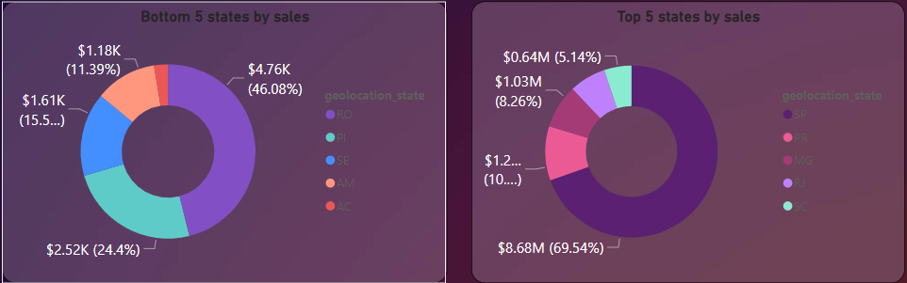

* As presented in the above chart is the categorisation of state-wise data and the profit percentage generated by the states and the lowest generated profits by states.
* Seasonal Sales Patterns: Investigate and visualize any seasonal patterns(Quarterly) or trends in sales data over the course of the year.
* In the dashboard we have added the slicers to identify the quarterly pattern in which we can see in start of the month since February the sales are going up and are consistent till sep and then pretty low til jan the same we can identify in quarterly data.
* Revenue Analysis:Determine the total revenue generated by ShopNest Store and analyze how it changes over time. Represent this information through suitable visuals to highlight trends and patterns.

* Aniket shankar Lore